Dr. Phillip W. Williams
5710 Tannahill Circle
Huntsville, Alabama 35802
(256) 882-2792

PROFESSION: Consultant
EXPERIENCE: 35 Years
EDUCATION: DPA/ Public Administration / 1978 / Nova University
MPA/ Public Administration / 1977 / Nova University
MAS/ Administrative Science / 1977 / University of Alabama in Huntsville
BS/ Mathematics and Physics / 1961 Florence State College (UNA)
National Defense University / 1981 and other US Army schools
Defense Systems Management College, Project Managers Course

PROFESSIONAL
REGISTRATION: Formerly an NASD Broker-Dealer and Registered Securities Representative;
Formerly an Insurance Agent

EXPERIENCE: Dr. Williams served as the Finance Director for the State of Alabama, responsible for all financial transactions of the State, Capitol Police, Facilities Maintenance, State Printing, Purchasing, Comptroller activities, and 48 State Committees and boards. He now consults with businesses regarding management, organization, strategic planning and business plan development, and with defense industries regarding defense issues. As a former securities dealer he formed a number of syndications and church bond issues. He was a Republican Candidate for Governor of Alabama in 1998. Dr. Williams was the District Governor, Rotary District 6860, and Rotary International Presidents Representative to District Conferences. He served on the State GOP Steering Committee; the Madison County Republican Executive Committee; and various Republican working groups. He has served as National Vice President, Southeast Region, American Defense Preparedness Association; Past President, Rotary Club of Greater Huntsville; Trustee, University of North Alabama; Director, UNA Foundation; Chairman, Huntsville Riverwalk Planning Committee; and has served as a Director, on a number of civic and community groups, to include Association of the United States Army; Huntsville/Madison County Chamber of Commerce; North Alabama Better Business Bureau; Huntsville/Madison County Council of International Visitors; and Alabama Constitution Village.

Before Dr. Williams began consulting he founded and organized a communications business operating in multiple Alabama locations providing long-distance telephone service to business and residential clientele. The company continued to grow and the multimillion-dollar operation was subsequently sold. He then formed an NASD Broker-Dealer Firm of which he was the securities principal until he began consulting full time, after which the firm was dissolved.

After graduating from college, Dr. Williams entered the US Army and served over twenty –two years on active duty before retiring. During his military career he served as Project Manager for developing multimillion-dollar military hardware systems, including serving as the first PM, Laser Designators; Commanded several units from platoon to battalion & squadron; staff officer at various echelons of the US Army; and directly coordinated US Army activities with foreign governments. He served two tours of duty in the Republic of Vietnam, first as an Adviser to a Vietnamese Army Infantry unit and subsequently with the 11th Armored Calvary Regiment.

During his military service and subsequently, Dr. Williams has chaired and worked on numerous technical and managerial committees at the local and national levels, to include the Precision Guided Weapons Working Group, Joint Service Laser Working Group, command reorganization committees, etc. When Alabama Finance Director he chair or served on 48 board/committees.

He is married to Ramsey Waddell Williams and they have 5 sons and 13 grandchildren.
Dr. Phillip W. Williams (Continued - 2)

Honors:
Listee: Who’s Who in the World
Who’s Who in America
Who’s Who in the South and Southeast
Who’s Who in Finance and Industry
International Men of Achievement
Jane’s Who’s Who in Aeronautics and Aerospace

Recipient: Legion of Merit; Bronze Star w/V device and 5 Oak Leaf Clusters; Meritorious Service Medal w/ 3 OLCs; Air Medal w/V device, 2 OLCs and Number 7; Army Commendation Medal w/V device and 4 OLCs; National Defense Service Medal; Cold War Service Medal; Army Service Medal; Overseas Service Medal w/Number 5; RVN Gallantry Cross W/Silver Star; RVN Technical Service Medal First Class; RVN Honor Medal First Class; RVN Campaign Medal w/7 stars; RVN Service Medal w/date device; Combat Infantryman’s Badge; Presidential Unit Citation w/ 2 OLCs; Valorous Unit Award; Meritorious Unit Citation; Republic of Korea Presidential Unit Citation; Republic of Vietnam Gallantry Cross w/2 Palms; Republic of Vietnam Presidential Unit Citation; Vietnam Campaign Civic Action Award; Vietnamese Armor Badge; Vietnamese Infantry Badge; Vietnamese Signal Badge and numerous letters of commendation, appreciation, and achievement.

Resolution of Commendation for Outstanding Service, Alabama State Senate, 1985;
Inductee, Hall of Heroes, Madison County, Alabama.

ASSOCIATIONS/SOCIETIES:
Association of the United States Army, 1961—
Blackhorse Association, 1970- Life
American Defense Preparedness Association, 1980— (Life)
American Society for Public Administration, 1975-84
National Association of Securities Dealers, 1985-91
American Legion, 1983- (Life)
Veterans of Foreign Wars, 1983- (Life)
Republican National Committee, 1984 – (Life)

CIVIC:
Rotary Club of Greater Huntsville, 1989-
Director, University of North Alabama Foundation, 2002-
Trustee, University of North Alabama, 1995-2000
Huntsville/Madison County Chamber of Commerce
Director, North Alabama Better Business Bureau, 1983-90

EDUCATIONAL:
Invited Lecturer, Cambridge University, Cambridge, England
Invited Lecturer, various British military schools (e.g., Royal Military Academy, Sandhurst)
Adjunct Professor, University of Alabama in Huntsville (Management and Finance)
Assistant Professor, University of Mississippi, Oxford, Mississippi (Military Science)

LICENSES/COMMISSIONS:
Finance Director, State of Alabama, 1995-96
Deputy Sheriff, Lauderdale County, Alabama, 1959-61
Officer, United States Army, 1961-83
Licensed Securities Broker-Dealer, NASD & Securities Exchange Commission, 1985-91
Insurance Agent, State of Alabama, 1998-04
Officer, United States Disaster Relief Command, 2010-

Dr. Phillip W. Williams (Continued -3)

ROTARY INTERNATIONAL

ROTARY ASSIGNMENTS

Rotary International
President’s Representative to District Conference (03-04; 04-05; 05-06)
RI Membership Zone Coordinator (03-05)
RI World Affairs Committee (04-05)
RI Convention Credentials Committee (05)
RI Convention Presenter, Interfaith Service (05)
RI Council on Legislation (Alternate)

Zone Institute
Presenter (03-04; 04-05)
Panelist (02-03; 03-04; 04-05)
Recorder (02-03)
Coordinator (02-03; 03-04)
Sergeant at Arms (03-04; 04-05)
DGE/N Trainer (04; 05; 06; 10; 11)
Chairman, House of Friendship (04-05)
Executive Committee (06; 10; 11; 12)

ROTARY RECOGNITIONS

Citation for Meritorious Service, The Rotary Foundation
Paul Harris Fellow (9)
Major Donor, The Rotary Foundation
Bequest Society (2)
District Service Award, The Rotary Foundation

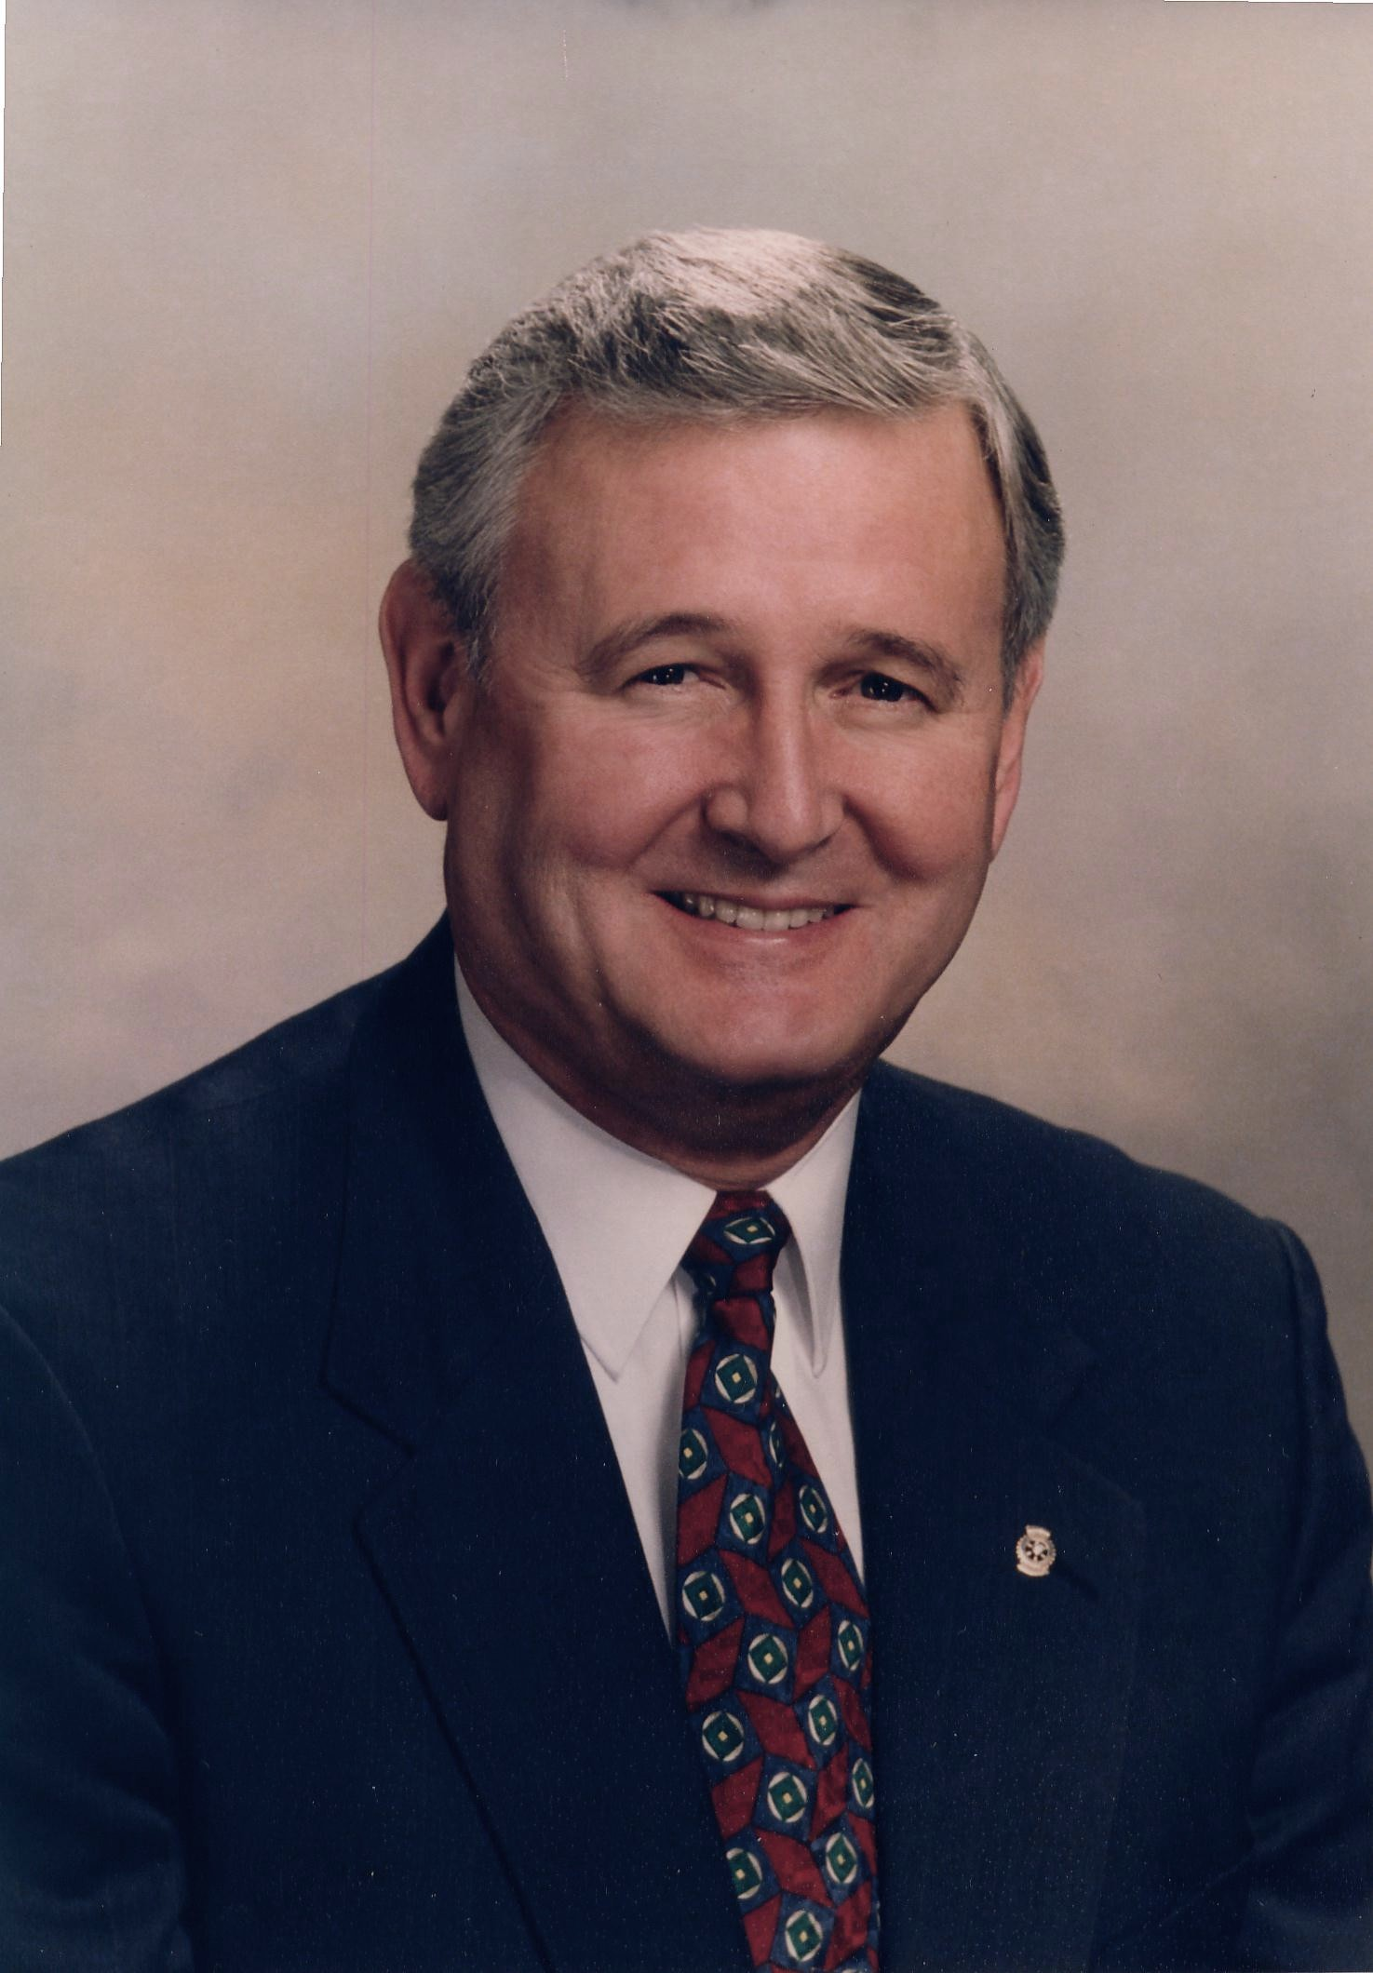

Dr. Phillip W. Williams

